**Practical Exercise - Walkthrough**

**Depending on what mail server / client you are using, the properties due to be set might be different, however the logic and activities would be similar. When using in this walkthrough Get Outlook Mail Mail Messages, it refers mostly to Get XXX Mail Messages, which XXX could be POP3, IMAP, Exchange, Outlook.**

We will start by dragging an activity **Get Outlook Mail Messages**, we configure which account to read from (if we need one which is not the default account in Outlook), the folder to read from and we create a variable in which the emails will be output. Let’s call this variable, **emails**

We will also use a **Read Range** activity to read the “rules” from the email rules.xlsx file, provided as input. We will Output the result into a DataTable which we will call **mailRules**

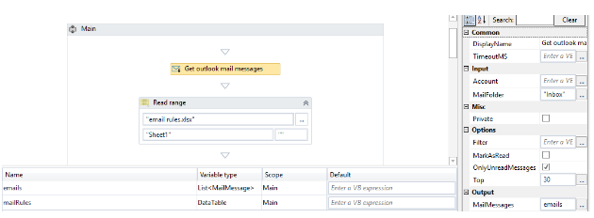

Notice that the **emails**variable, created by us in the output property of Get Outlook Mail Message, is of type *List<MailMessage>*

As we are trying to apply the rules to each email, we will create an iteration on this **emails**list by using a **For each** activity. Considering the list we are iterating consists of *MailMessage*objects, each item from the iteration will be of type *MailMessage*and we need to specify this explicitly.

We click on the **For each** activity and in the property called TypeArgument, we choose from the options in the list, the value System.Net.MailMessage.

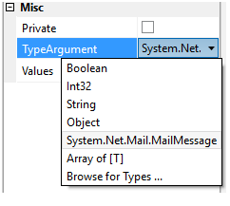

If this option is not on the list, please click on **Browse for Types** and search for the System.Net.Mail.MailMessage in the appearing dialog window.

Now we need to iterate on each of the rules and see if the current mail we are analysing meets any of the criteria. This time we have a DataTable object so we will iterate it much more comfortable with a **For each row** activity. The only thing you need to specify is the object to iterate on, which in our case is **mailRules**

We now need to check if the rules on the subject apply. As we have access to the current email in the item (we renamed it to mail) variable created automatically and this variable is of type

MailMessage, we can access all specific mail properties. We have to see if the Sender.Address property contains the column “Sender” from the current rule being checked

If that is true, we use a Move Outlook Mail Message and we move the current mail to the folder that is specified in the current row on column “Folder”

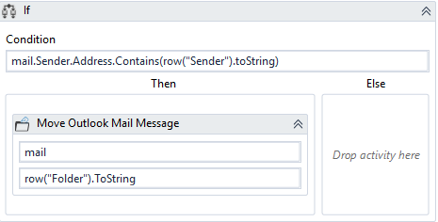

We also need to add a break to this sequence, in order not to verify the other rules anymore, if one was already applied and the mail was moved to another folder.